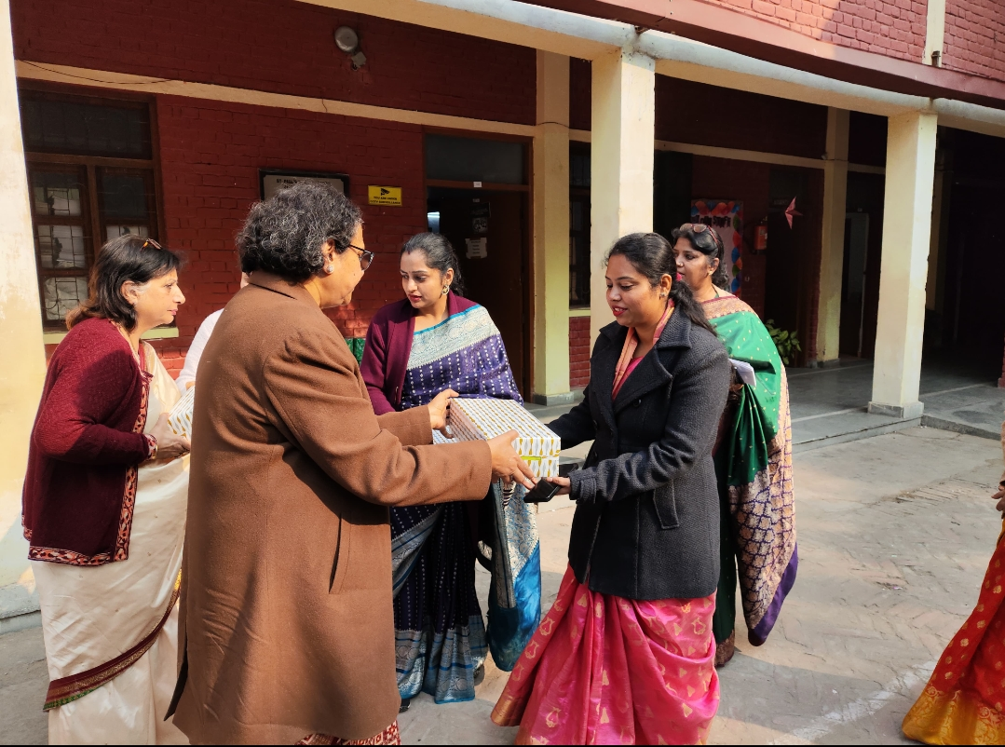
ST. PAUL’S DIOCESAN SCHOOL
JANGPURA, DELHI
Annual Report 2024–2025
“Give thanks with a grateful heart…” (1 Thessalonians 5:18)
"In everything give thanks; for this is the will of God in Christ Jesus concerning you."
With hearts full of gratitude, we acknowledge the goodness of the Lord, the tireless efforts of our staff, and the enthusiasm of our students. Together, we stand as one family, faithful to the mission entrusted to us. It is with great joy that I present the Annual Report for the Academic Year 2024–2025.
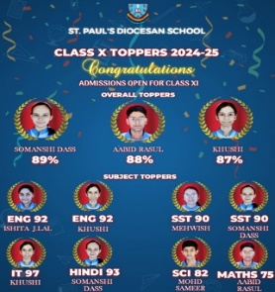
This year, we witnessed God’s abundant grace in every challenge and success. Alongside academic excellence, our students actively engaged in a variety of co-curricular and social initiatives that nurtured their values, discipline, and holistic development along with achieving great excellence in academics.
Class XII Results-2024-2025
- Number of students appeared: 25
- Total number of distinctions: 56
- Highest percentage obtained:96

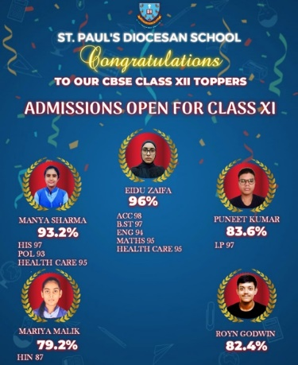
CLASS X RESULT 2024-2025
- Number of students appeared: 27
- Total number of distinctions:41
- Highest percentage obtained:89

SENDING OFF CEREMONY
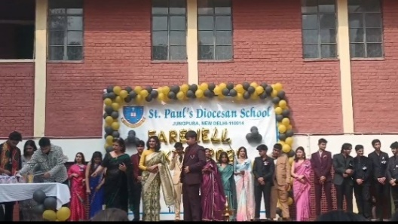
“Each ending is but a new beginning, each farewell, the start of a song still singing”
After completing more than a decade in the school, and embarking upon a new journey, the staff and the junior students gave a befitting send off to the dear students commissioning them to carry the school torch forward armoured with the values they absorbed over the years.
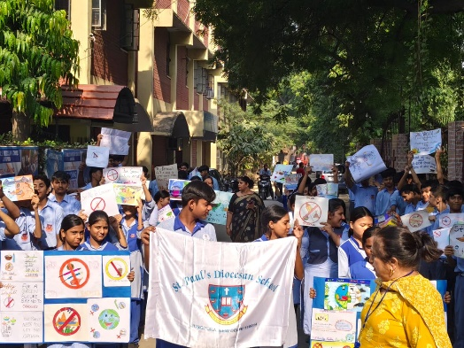
Environmental Care
  - In collaboration with the Rotary Foundation, our students undertook the Save the Seed Project, initiated by Dr. Santosh George, working towards making Delhi green and pollution-free.
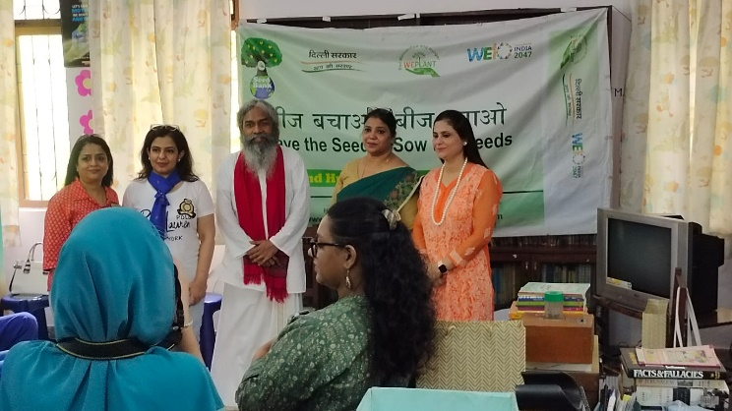
  - Rotary Club Foundation awarded Scholarship to our most deserving candidate.
  - They also carried out an Anti-Cracker Drive March to spread awareness about protecting the environment.
  - The students carried out competitions outlining the measures to save the environment.

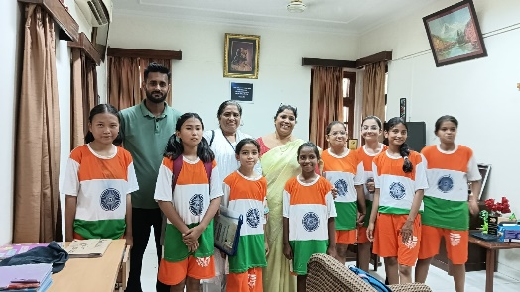
Sports & Team Spirit
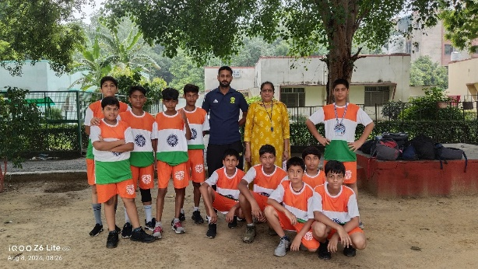
Being the proud winners of Zonal Volleyball Competition, our students acquired first position for the sub-juniors’ girls’ team and Third position for Boys Sub-juniors’ team.
Not only being the players, our students extended their support to the Senior Women Hockey Inter-Department National Championship teams and cheered them on as the marched towards the national victory.
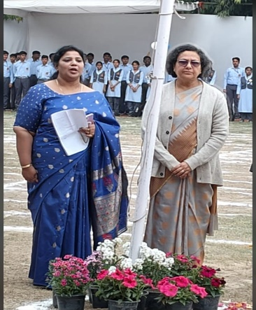
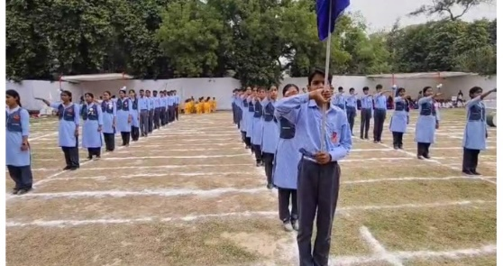
The school also celebrated Sports Day 2024-2025, highlighting the importance of discipline, agility, and the belief in a sound mind within a sound body. The academic year witnessed a vibrant display of sporting spirit among our students. The Annual Sports Day was the highlight, featuring track and field events, relays, and fun races. Fitness activities such as aerobics sessions and morning drills were also conducted regularly to promote physical well-being. The Day was a testament of the concentration and strategy.
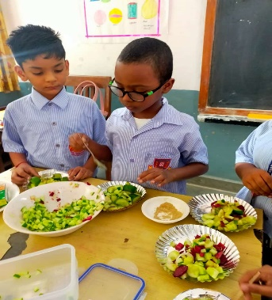
Health & Nutrition
Students participated in activities promoting healthy diets, including preparing simple, nutritious breakfasts. They also explored The Power of Millets through a project initiated by Tata Soulful, encouraging them to adopt sustainable food habits.
Celebrating World Health Day
While teaching our students good value education, sports and academics, teaching healthy food habits is equally important. The students learnt how to create healthy cuisines.

Learning Beyond the Classroom
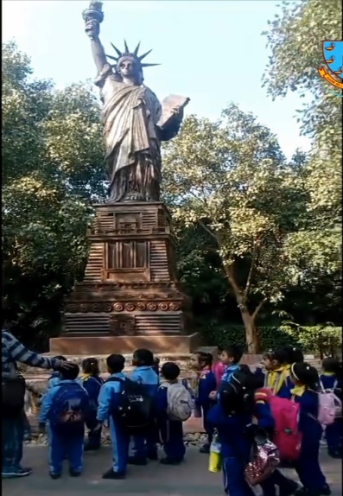
To instil the value of reuse and recycling, our students were taken on a picnic to Waste to Wonder, where they learned that not all that is thrown away is garbage—many things can be reused meaningfully.
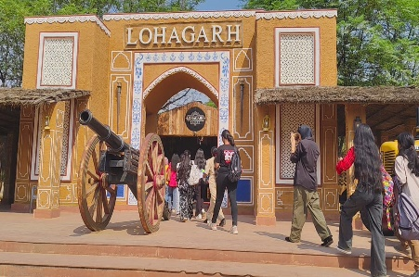
Living in the cities, the students have drifted away from the villages. The senior Students were taken to Lohagarh Farms to give them a hands-on experience of the rural life.

Celebrations & Values:
  - On Children’s Day, teachers expressed their love and dedication by performing for their students.
  - During Christmas, our students carried the message of joy, peace, and goodwill to all.
  - Republic Day was celebrated with pride, evoking the patriotic spirit of our nation.
  - Helpers’ Day
  - Grand- parents Day

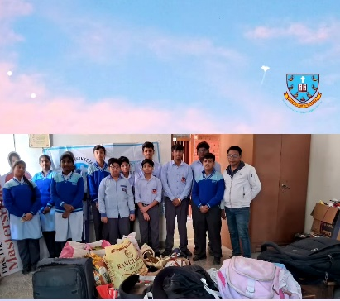
Social Responsibility: Our students collected old clothes and household items for social work, sharing the message of compassion and service. Collaborating with Sarva Hitam Manav Sewa Sanstha the students interacted with the less fortunate sections of the society to bring joy and the message of love thy neighbour into the lives of many underprivilege section of the society.
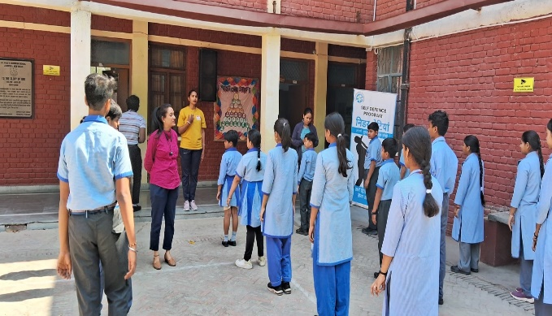
Safety & Empowerment: In collaboration with Delhi Police, students received Self-Defence Training, equipping them with confidence and self-reliance.

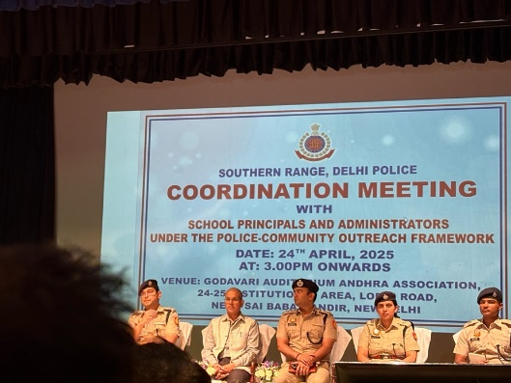

Empowering the Mentors
“When Teachers learn the world learns too, for knowledge passed on is ever true.”
Only when the teachers are equipped with skills can they guide the others. Keeping the guidelines of the DoE in mind the teachers were encouraged to attend regular workshops organised by the school not only through the CBSE portal but also through various Educational Agencies.
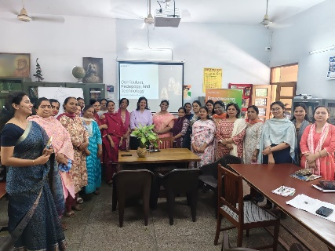
- Workshop on Mental well Being among students- Suraasa
- Workshop on Financial Literacy- CBSE
- Workshop on Understanding Adolescence- Hindustan Times
- Workshop on Art-Integration-CBSE
These activities reflect not just achievements but also our school’s deep commitment to shaping responsible, compassionate, and confident citizens of tomorrow.

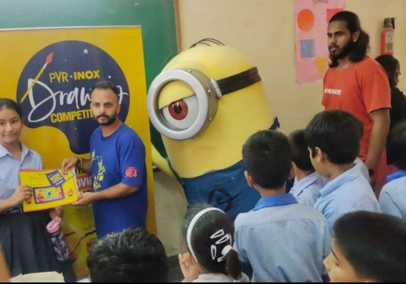
“Another Year has passed with stories of laughter and learning, of challenges and triumphs of achievements and yearnings.
Every child a verse, each teacher, a guiding rhyme, together weaving a melody etched in the wheel of time. May the coming year be another chapter richer, brighter and ever more inspiring and prime.”
Grateful and humbled note of Thanks to:

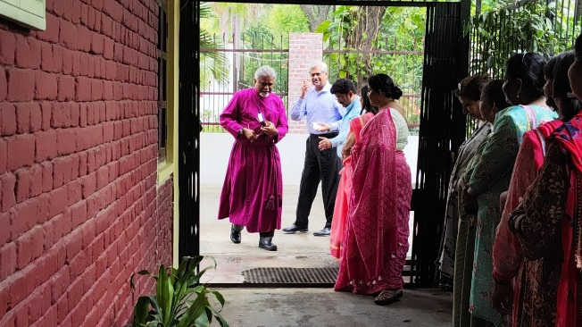

Rt. Rev. Dr. Paul Swarup
Bishop Of Delhi, Church of North India, and
Chairman of Our School

Rohini J. Das Dr. Anuradha Amos
Principal Hon. Manager

